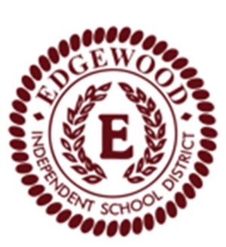District-Wide Educational Improvement
Council (DEIC)

------------------------------------------------------------------------------------------------------------------------------------------

Calendar of Meeting Dates
2022 - 2023

- September 29, 2023

- November 17, 2022

- January 19, 2023

- March 9, 2023

- May 18, 2023

